2023 Big Bass Challenge Info Sheet
Lake Murray

Tournament Date: 5/21/2023
Lines in at 7:00 am EST

Weigh Site
Dreher Island State Park
Shelter #15 3677 State Park Rd Prosperity, SC 29127

Weigh Periods
7am – 8:59am
9am – 10:59am
11pm – 12:59pm
1pm – 2:59pm

Guaranteed Payout Each Pay Period
Place | 200+ anglers | 1-199 anglers
1st | $ 1,500.00 | $ 750.00
2nd | $ 900.00 | $ 450.00
3rd | $ 600.00 | $ 300.00
4th | $ 450.00 | $ 225.00
5th | $ 300.00 | $ 150.00

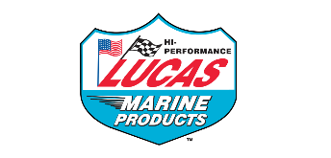
Prize Drawings for fish weighed each period from each of the following companies:

“Total Boat Makeover” Grand Prize for heaviest bass: $5,000 Gift Card for use on Strike King or Lew’s product

Pro Night, Onsite Registration
Location: Palmetto State Armory
3760 Fernandina Rd Columbia, SC 29210
Date: 5/20/2023
Time: 3pm - 6pm

*FREE Lew’s Gift Card for first 100 to pre-register. Must be picked up onsite 5/20/2023.

Page 1

